

MycorrhizaFinder
Quick-Start User Guide

Tool version: V5.0.0



Summary
This document is intended to enable new users of the MycorrhizaFinder tool to quickly get started with the tool, assuming no prior context. For fully exhaustive documentation, see the Full User Documentation.
MycorrhizaFinder allows for high-throughput computer vision-based identification and quantification of Arbuscular (AM) and Ericoid (ErM) Mycorrhizal fungal colonisation using convolutional neural networks.
This version of the MycorrhizaFinder tool has been developed by the Royal Botanical Gardens Kew through the Natural Capital and Ecosystem Assessment (NCEA) programme. The NCEA is Defra's largest research and development programme, it is generating a robust evidence base of the location, extent and condition of our natural capital and ecosystems, and how the state of nature is changing over time. The original tool was developed by the Sainsbury Laboratory, University of Cambridge (see Evangelisti et al. 2021, https://doi.org/10.1111/nph.17697).

Contents
Summary 2
01. Tool Installation 4
01.01 Installing Postgres 4
01.02 Running the executable 4
02. Tool Usage 5

Tool Installation
In order to install the tool for use, there are only two prerequisites: you must have the correct executable downloaded for your Operating System (OS), and you must also have Postgres installed, which is the database the tool uses to store data. The current version of the tool has executables for Windows, MacOS and Linux operating systems. The Postgres database is the local solution for storing annotations and predictions. Instructions on how to install Postgres and run the executable are included below.

Installing Postgres
You can install Postgres via the official website here. Select the relevant OS and follow the download instructions. If prompted to choose a password, choose postgres.

Running the executable
Once you have downloaded Postgres and started it on your machine (this should be automatic), you can run the tool by simply double clicking the executable for your OS (e.g., amf.exe on Windows). This will automatically open a command line interface that is running the tool, and will also open a web browser window at the address http://127.0.0.1:8001. This may take a minute to load. Once it has loaded, see the instructions in the following section to follow the default user workflow.
To stop the tool, just close the command line interface. The interface in the web browser will then stop working, so you can also close this.
Note: the executable comes with a folder called _internal. This must stay in the same folder as the executable, i.e. the exe and the _internal folder must always stay together.

Tool Usage
This section describes the default user workflow. For more advanced functionality or troubleshooting, see the Full User Documentation.
- When the tool loads, you will be presented with a screen like the following:
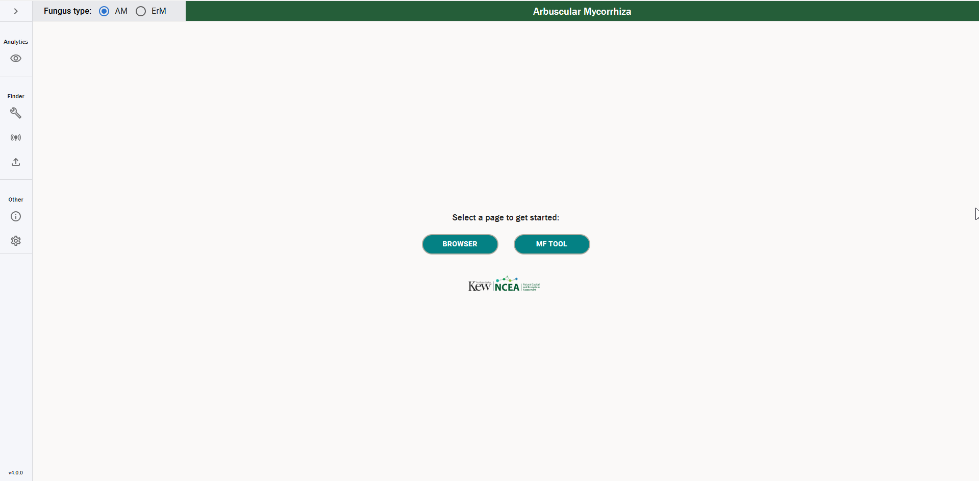
- Choose “MF Tool”. You will be presented with a screen like the following:
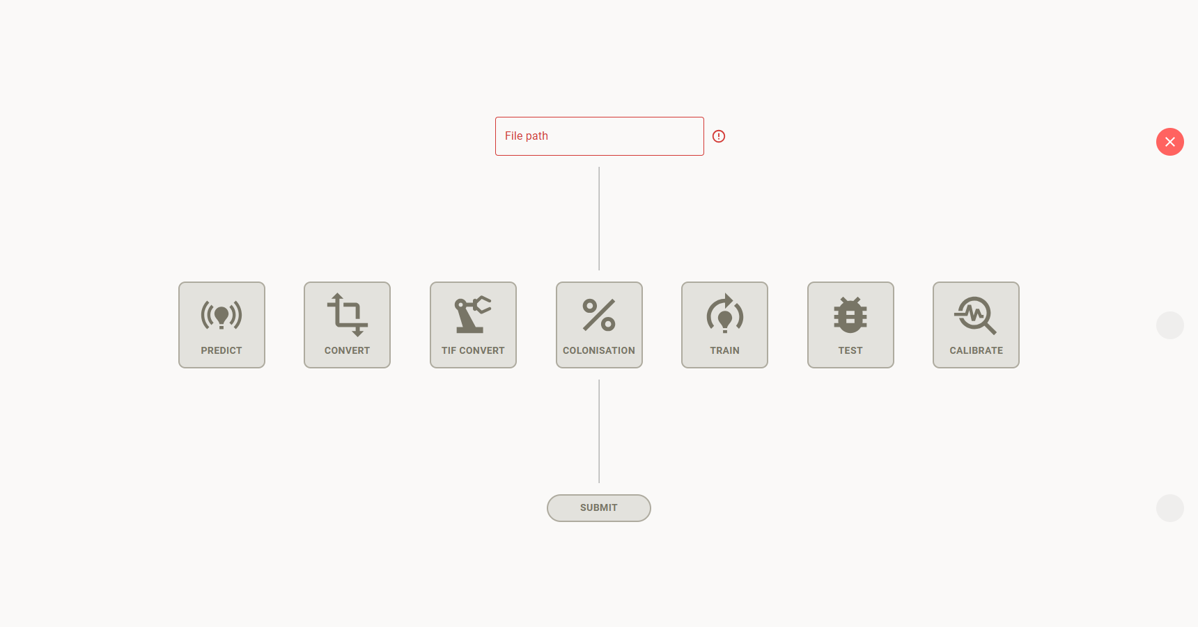
- In the “File path” box, paste the address to a folder containing images to be processed. This must be a folder, rather than a single image, and all JPEG files (.jpg or .jpeg extension) in the folder will be processed.
- Select “Predict” mode, the left-most icon in the middle row.
- Press “Submit”. You should see a message that predictions are now underway.
- Optionally, you can switch to the terminal console to view the progress of the predictions. It will typically take a few minutes per image, though this can vary depending on the size of the image and the hardware it is running on. Eventually you should see a message in the tool that predictions have successfully been generated.
- Switch to the Browser mode in the left sidebar. This is the eye icon at the top of the sidebar, which will look like one of the following screenshots, depending on whether the sidebar is expanded or collapsed:
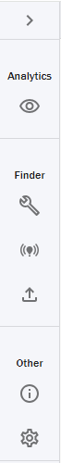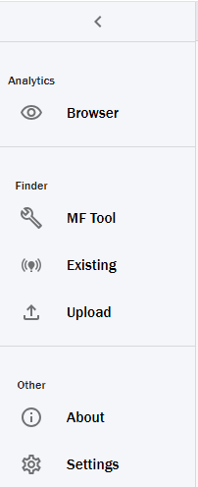
You will be presented with a screen like the following:
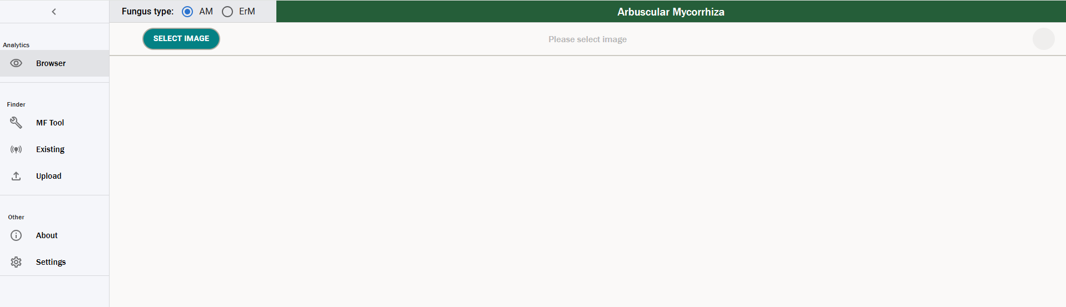
- Choose “Select Image” and select one of the images that you have just produced predictions for. You should see the newly generated predictions presented in a table like the following:
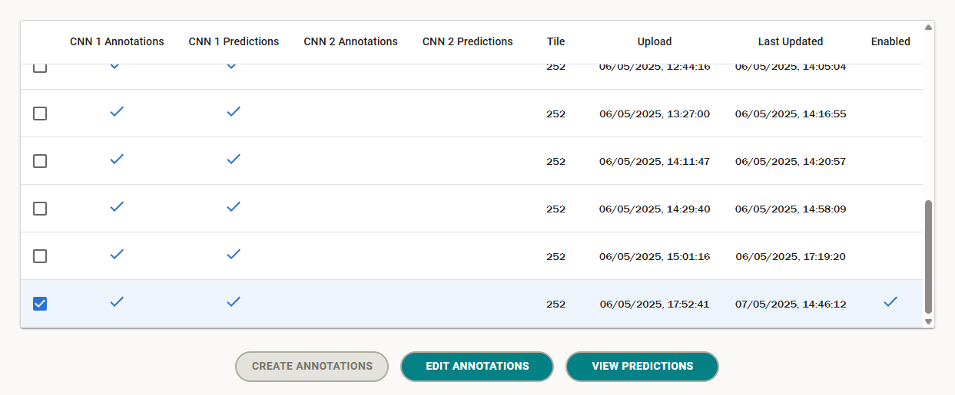
- Choose “View Predictions”. After a short wait for the image to load, you should be presented with a screen like the following:
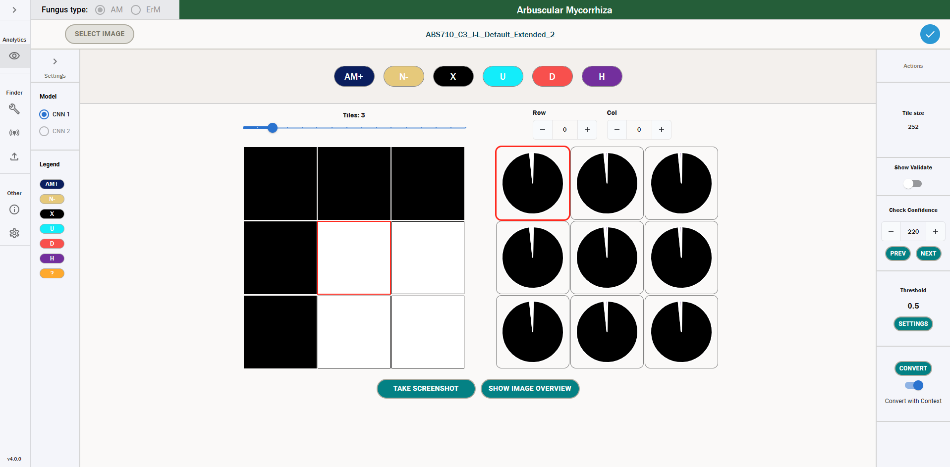
The image has been divided up into small tiles. By default the top 3 rows and leftmost 3 columns of tiles are shown at first. You can navigate between tiles either using the arrow keys, by clicking on adjacent tiles or by using the “show image overview” function. Each pie chart represents the model’s estimated probability that the corresponding tile belongs in each of the following classes:
  - AM+: arbuscular mycorrhiza (AM) colonised root;
  - N-: uncolonised root;
  - X: background, i.e. not part of the root;
  - U: unreadable;
  - D: dark septate endophyte (DSE) colonised root;
  - H: hybrid colonised root, containing both AM and DSE colonisation.
More information on these model classes is contained in the Full User Documentation.
The pie chart follows the colours in the list of classes at the top of the screen, and you can also identify the classes in the pie chart by hovering over each part:
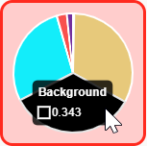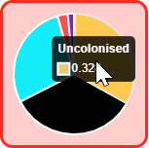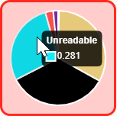
For some tiles, the model prediction has a high confidence, meaning that it has assigned the tile to a particular class with a high probability. This is often the case with plain background tiles, like those visible in the screenshot above. For other tiles, the confidence is lower.
- You can use the “Check Confidence” buttons in the right sidebar to step through all tiles in order of increasing confidence, where 0 is the least confident tile. It is recommended that you manually inspect every tile prediction. If you disagree with the model’s choice of most probable class for a particular tile, you can correct it by selecting the tile and clicking the button for the correct class at the top of the screen. Alternatively, you can use keyboard shortcuts: A/N/X/U/D/H.
- Once you are satisfied, you can proceed by converting predictions to annotations. This works by specifying a confidence threshold between 0 and 1: above this threshold, tiles are assigned to the most probable class, which is useful for high-confidence background tiles, which are generally correctly predicted and do not need correcting. Below the threshold, only manual annotations are retained. If you follow the recommendation of manually inspecting every tile prediction and correcting any errors then it is safe to specify a threshold of 0, meaning all tiles are carried forward to the colonisation metric calculations for maximum accuracy. Once you’re happy, press Convert to make the conversion.
- Once annotations have been created, you can return to the Browser. If you select the image you have just created annotations for, the annotations should now be visible in the Browser. Choose “Edit Annotations”, and once loaded, the image’s colonisation metrics will be visible in the right sidebar, like in the screenshot below:
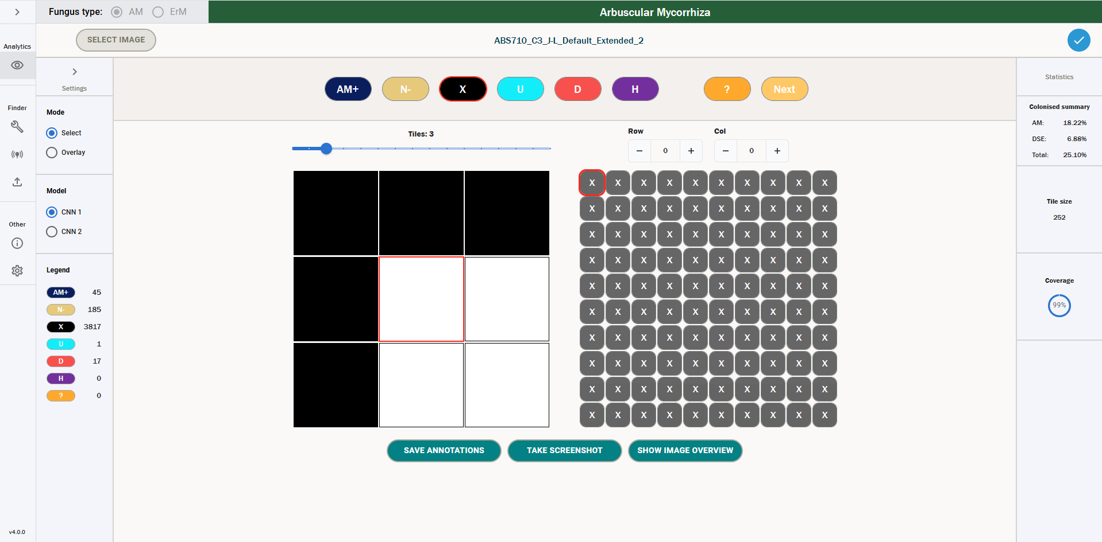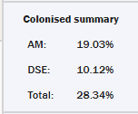
These are the colonisation metrics for this image.
Congratulations! You have completed the basic workflow. For any more advanced functionality or troubleshooting, please consult the Full User Documentation.

